Booklet for Technical Writing in MS Word

# Introduction and basic setup

## Setting up Word

In the setup stages there are two main tasks that are recommended to be performed. They are setting up the rulers, and knowing how to add or remove the paragraph marker.

### Viewing/Hiding the Ruler

In order to view or hide the ruler you need to go to View, Show, Ruler. Here you find a checkbox. Simply check the box to view, and uncheck the box to hide, the ruler. Figure 1 illustrates this action.

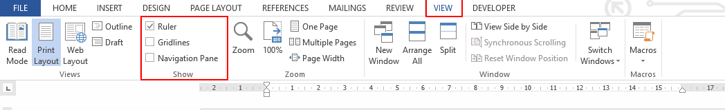

**Figure 1:** The operation of viewing/hiding the ruler.

### Adding or removing the paragraph marker

The paragraph marker is a very useful tool when you are using Word. In order to hide/view the paragraph marker, simply go to Home, Paragraph, ¶. Figure 2 better illustrates this action.

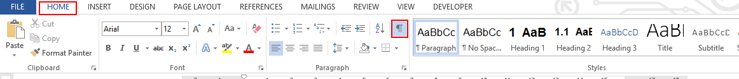

**Figure 2:** The operation of viewing/hiding the paragraph marker.

### Saving a template

When you have done all the programming with styles and they are exactly as you like them, you can save the setup as a template. Simply go to File, Save As and when prompted, you can select Save as Template from a dropdown menu. The template can then be opened each time you start up Word by selecting Personal templates, and the name of your saved template. Figure 3 and Figure 4 illustrates how to save and open a template.

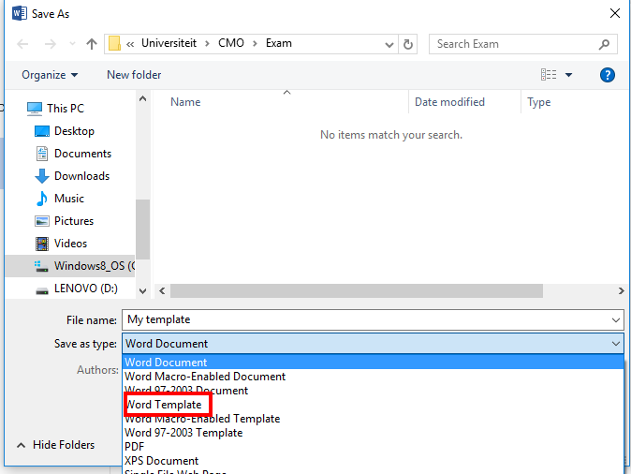

**Figure 3:** The Save As Dialog that will be presented when trying to save a template.

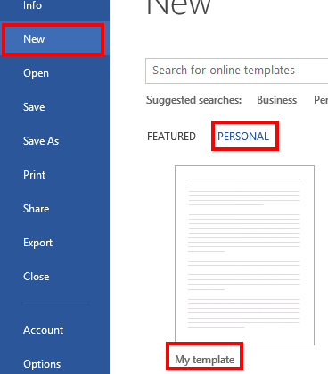

**Figure 4:** Opening a saved template in Word

# Font size, Line Spacing and Paragraph Spacing

This whole section originated in 1868 when the art of typewriting was invented. We only use a broadly simplified form of the art. To understand how line and paragraph spacing works, you have to dig deep into the pre-set definitions that originated with typewriting.

## Understanding the theory

### Font size

Figure 5 illustrate the main definitions regarding the layout of different fonts. The most important lines to note is the baseline, the ascender line, and the descender line. The font size is measured in points, so that 72 points = 1 inch. The font size in points is measured from the ascender line to the descender line.

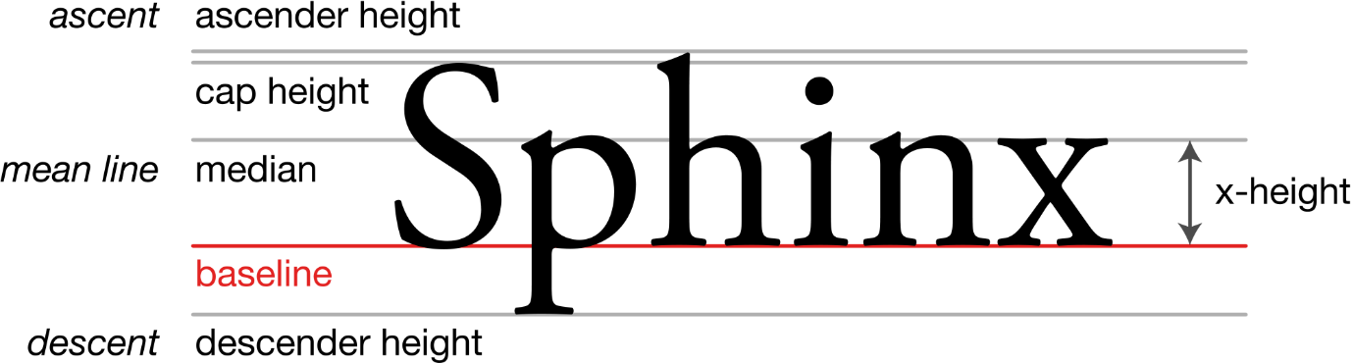

**Figure 5:** The basic layout of a font.

### Line spacing

Line spacing in Word is given as a ratio based on the font size. This ratio is always greater than or equal to one. The common formula is

|  |  |  |
| --- | --- | --- |
|  | $$Line space=Ratio(Font size)$$ | (1) |

The distance, in points, resulting from Equation (1) is the distance between the baselines of different lines of text. Figure 6 provides an illustration.

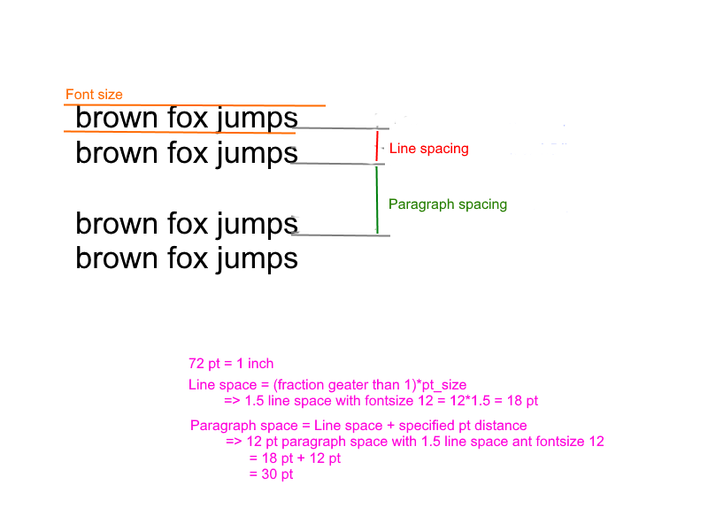

**Figure 6:** An illustration of font size, line- and paragraph spacing.

### Paragraph spacing

In Word, paragraph spacing is defined as a distance in points. This distance is added to the line spacing at the beginning or the end of a paragraph. An equation that will suffice is

|  |  |  |
| --- | --- | --- |
|  | $$Paragraph space=Line space+Specified distance$$ | (2) |

The distance obtained from Equation (2) is the distance between the baselines of the opening and closing lines of text from the two separate paragraphs. Figure 6 provides an illustration of the above mentioned concept.

## Adjust font size, line spacing and paragraph spacing in Word

Font size is very easy to adjust. Simply go to Home, Font, Font size and click on the dropdown menu to select a specific size. Otherwise, you can use the Increase font size, or Decrease font size tools. Next the drop drown menu for font size, there is another drop down menu where you can adjust the font style. See Figure 7 for more detail.

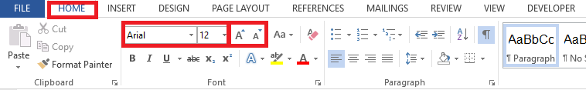

**Figure 7:** Adjusting font style and font size.

To adjust the line spacing of multiple paragraphs, you need to highlight the multiple paragraphs in order to select them. If you only want to adjust the spacing of one paragraph you only have to make sure that your typing curser is within the paragraph of which line spacing you will be adjusting. Line spacing can be adjusted fairly effortlessly by going to Home, Paragraph, Line and paragraph spacing. Then you just have to select the desired line spacing. Figure 8 provides more detail regarding this action.

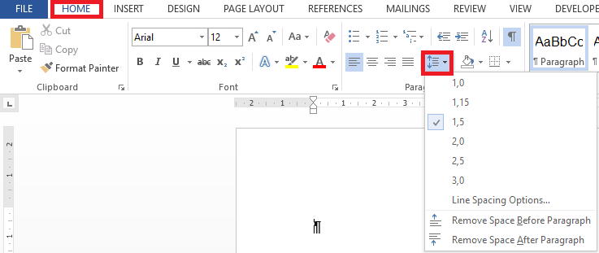

**Figure 8:** Adjusting the line spacing.

In order to adjust the paragraph spacing you need to open the paragraph settings. To do this you need to click on the bottom right symbol in your paragraph functional area group. Figure 9 illustrates the path.

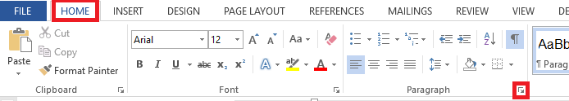

**Figure 9:** Open paragraph settings.

When you click on the indicated button, the link will take you the dialog illustrated in Figure 10.

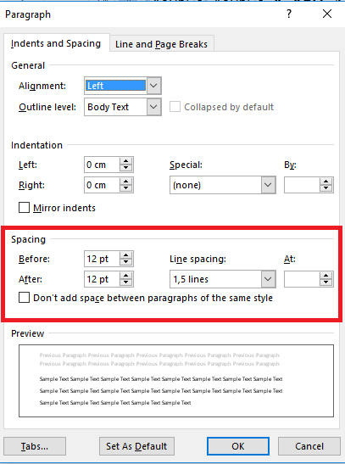

**Figure 10:** The paragraph settings menu.

Although there is a lot you can achieve by manipulating the variables in this menu, we are mainly interested in the variable under the Spacing group. It is fairly clear that you can now adjust the before- and after paragraph spacing as well as the line spacing by using this dialog. It is noteworthy that when you are optimizing your usage of Word, you will seldom, if indeed ever, user this way of adjusting the line and paragraph spacing. Section 3 will be on using styles, which will enable you format very big documents effortlessly.

# Styles

Styles are groups or certain paragraph formats. They are located under Home, Styles.

## Why would I use Styles?

If you are relatively new user of Word, you will at first question the necessity of using Styles. I can assure you that, although this may look like a lot of effort in the beginning it is most definitely worthwhile to understand and use Styles. In short, Styles group different types of text, like paragraphs, titles, headings, etc. You can then format the group according to your liking, and when you are done formatting all of the text in your document that you have categorized under this group, will be formatted as you have specified. It is needless to say that this may just save you hours in reformatting your document.

## Assign styles to text

In order to assign styles to text you first need to know that the different groups of text are separated by using paragraphs. Therefore you cannot assign two different styles to text that are located in the same paragraph. To assign the style you only need to make sure that you text curser is within the desired paragraph. You then go to Home, Styles and then you select what kind of text this is. See Figure 11 for more clarity.

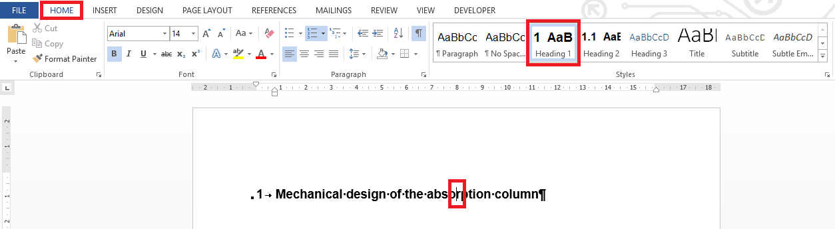

**Figure 11:** Assigning a style to text.

Figure 12 shows a list of all the styles that are available in Word.

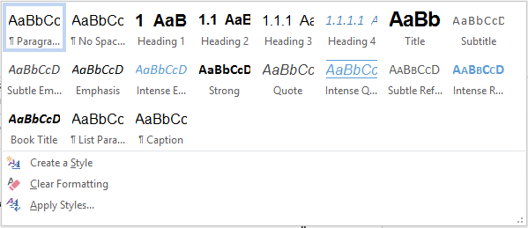

**Figure 12:** All the available styles.

## Formatting styles in Word

Typically you will need to deliver your document formatted in a very specific manner, specified by the person to which you will be submitting the final document. As mentioned before, you will be able to write your whole document, using styles, in a completely different format as the one specified, and at the very end format your styles. This will format the whole document in the correct format for submission.

### Formatting a style

To format a style you will need to open the specific style’s settings menu. To do this right click on the style and select Modify, as illustrated in Figure 13.

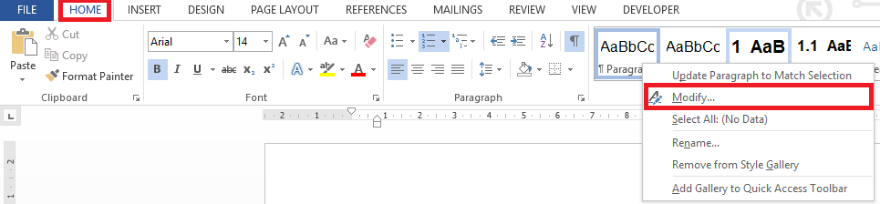

**Figure 13:** Opening the style formatting menu.

This will open the dialog in Figure 14. In this dialog you can set the name of the style, as well as the font size and –style, and also the justification of your text. To set the line and paragraph spacing you need to click on Format, in the bottom left corner, and then select Paragraph.

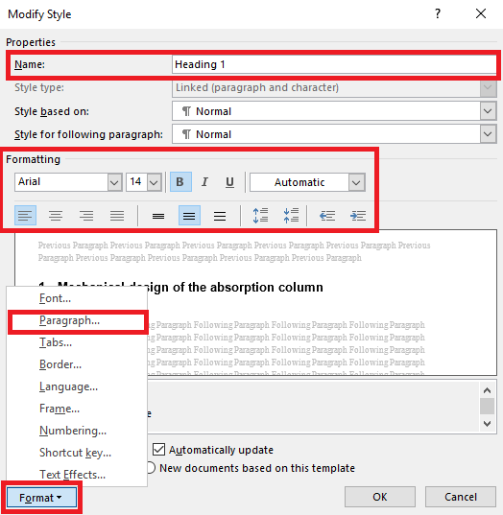

**Figure 14:** The modify styles menu.

When open the Format, Paragraph menu, the exact same menu as in Figure 10 is opened. You can therefore edit the line- and paragraph spacing as discussed in Section 2 for each separate style.

### Numbering your headings correctly

When you open Word, you will note that some heading are not numbered. In order to set the numbering of your headings in a multilevel list, like in this document, you will need to select Heading 1. Then go to Home, Paragraph, Multilevel list. Under the List Library select the list that is illustrated in Figure 15.

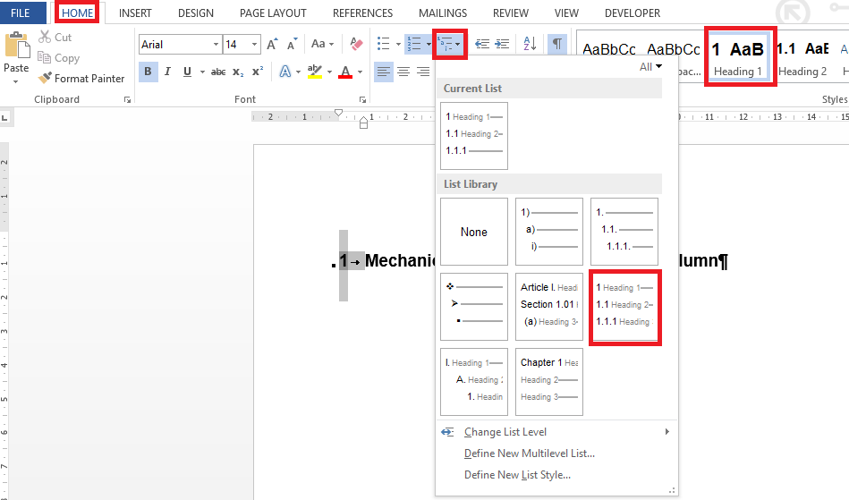

**Figure 15:** Insert a multilevel list for headings.

# Equations

In this section we will be discussing equations in Word. There are a lot of add-ins that you can use to insert equation into Word. I will however not discuss these programs, and to be honest I personally feel the built in equation editor in Word is quite adequate. There are a lot of ways to insert your equations. You can waste quite a lot of time clicking your through the equation editor in search of Greek symbols and the right mathematical operators. Word however have developed a lot of LaTeX shortcut to speed up the process of inserting your equation. This faster method will be discussed.

## Setting up a quick part for equation insertion

To format equations according to the desired centre justification for the equation and right justification for the number can be time consuming, therefore we would like to preferably only do this once and copy/paste our way through the rest of the equations. The only real problem is that the numbers for each equation will have to be modified at each equation. Word has solved this problem for us as well. We only need to insert a sequence. This will result in the sequential numbering of all of our equations. A stepwise list of how to create your equation insertion quick part is given below:

1. Insert a table with 3 columns and 1 row.
2. Move the vertical borders of the centre column toward the sides to create a fairly broad centre column.
3. Centre justify the middle column.
4. Go to Insert, Symbols and click on Equation. This will insert a blank equation.
5. Right justify the column on the right.
6. Go to Insert, Text, Quick Parts. Select Field.
7. Under Field Names find Seq. Click on Seq.
8. Under Field Codes there should now stand SEQ. Type in Equation after the initial three letters. (Spelling in this step is very important for cross referencing).
9. Click OK. A number 1 should now appear in the right column. Add brackets around the number.
10. Now remove the borders of the table.
11. Select the whole table.
12. Go to Insert, Symbols and open the drop down menu of Equation (just note that although Equation is grey and therefore deactivated the dropdown menu will still contain one active tool).
13. Click on Save Selection to Equation Gallery.
14. In the name tab you can fill in “Insert Equation”. Then click OK.

With the above steps completed the whole process, step 1 through to 14, has been saved as an algorithm. To insert the new blank equation just go to Insert, Symbols. Select the drop down menu under equation. Scroll down and select “Insert Equation”, under General. See Figure 16 for an illustration.

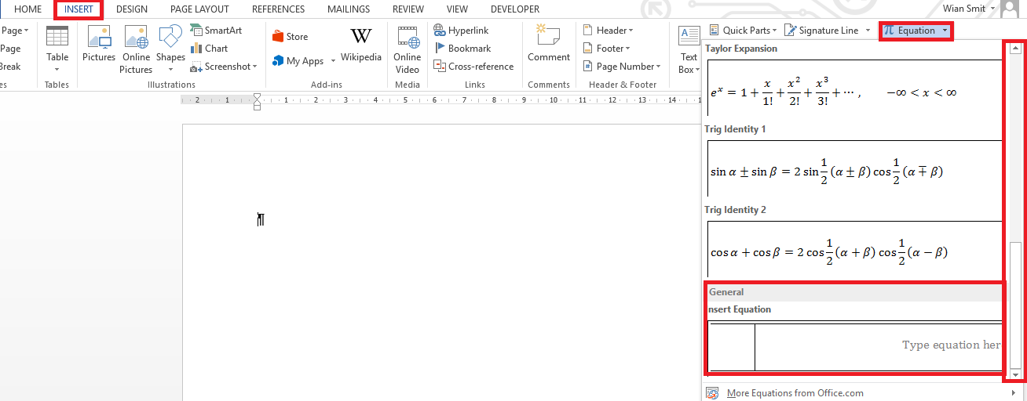

**Figure 16:** Insert the equation quick part you have saved.

Note now that if you insert multiple equations underneath one another the numbers of the equations will update automatically.

## Typing the equations

In order to speed up the process with typing you can type in equations using the LaTeX format. Table 1 illustrates a few of the basic shortcuts and their type method. In order to change the text into a neatly formatted equation you need to hit space when you are finished typing.

**Table 1:** Shortcuts for equation editing.

|  |  |
| --- | --- |
| Formatted equation | Typeset format |
| $$\frac{a}{b}$$ | a/b |
| $$\frac{a}{b+c}$$ | a/(b+c) |
| $$h_{o}$$ | h_0 |
| $$x^{2}$$ | x^2 |
| $$\int_{a}^{b}{x^{2}dx}$$ | \int <space> _a^b <space> <Ctrl+I> d <Ctrl+I> x |
| $$\sqrt{λ_{0}}$$ | \sqrt <space> \lambda_0 <space> <space> |
| $$\left[\begin{matrix}3 & t \\ 4 & x\end{matrix}\right]$$ | [ \matrix <space> (3&t@4&x) <space> ] <space> |
| $$\frac{∂f}{∂t}$$ | \partial <space> f / \partial <space> t <space> |

## Cross referencing an equation

To cross reference an equation open the Insert, Links, Cross-references displayed in Figure 17. This will open a menu like in Figure 18. Very important is to make sure you are cross referencing the correct type of object. You therefore need to select Equation in the Reference list dropdown menu. In the insert reference to dropdown menu, you can select “Entire caption”. This will insert not only the number of the equation but the brackets as well.

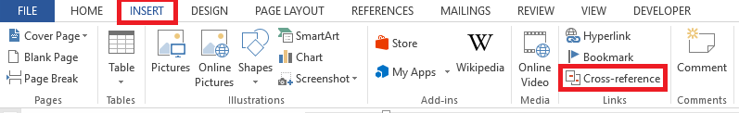

**Figure 17:** The cross-reference tool.

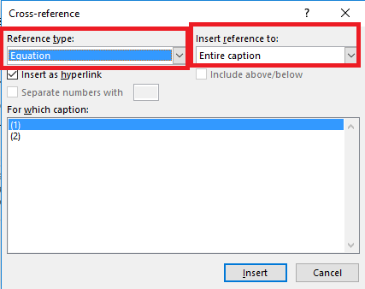

**Figure 18:** The cross-reference menu.

When the cross reference have been inserted the number in text and the number in the equation table will be updated simultaneously. You can check your cross reference by pressing Ctrl and clicking on the in text equation reference.

# Tables

There are two ways of inserting tables into a formal document. The one is manually using the Word tools, and the other is by importing tables via Excel.

## Manually using Word

This is a slow process, and I advise against using it. It is also a very straight forward way of inserting tables. Figure 19 shows the layout of the tool.

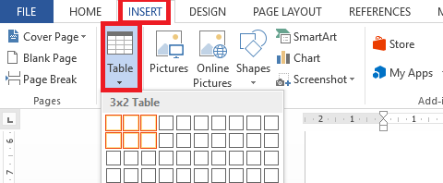

**Figure 19:** The Add a Table tool location.

To format the borders of the table click on the selection key in the top left corner of the table. Figure 20 illustrates this.

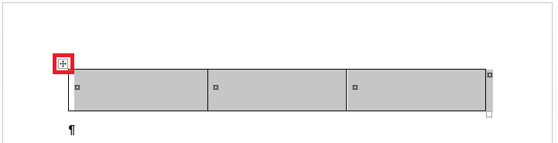

**Figure 20:** Table selection.

You now select borders, and then modify the different borders to your liking by using the quick access toolbar that appears when you hover over the key in Figure 20. Figure 21 shows this toolbar with the border adjustments dropdown menu displayed.

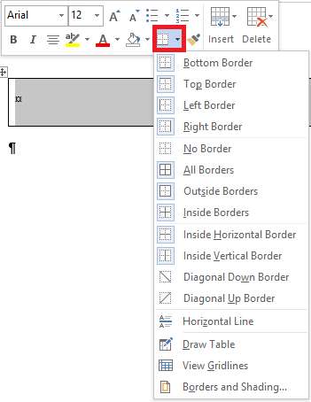

**Figure 21:** Adjusting the borders of a table.

## Import a table from Excel

This is useful especially when you are inserting data tables, because you are probably already working with Excel, and therefore already have the table you want to insert in this platform. All of the formatting will take place in Excel, and you will just copy and paste the cells into Word. In this operation every cell in Excel will represent a cell in a table in Word.

### Formatting the table

Excel also has a Borders tool. Figure 22 shows its location.

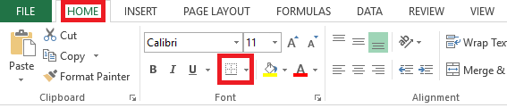

Figure : Borders in Excel.

With this tool you can insert various borders for your specified cell/table.

### Importing into Word

You just select all of the cells you want to import as a table and press Ctrl+C. Then in Word you press Ctrl+V to paste the cells, and your correctly formatted table is now imported into Word.

## Insert a citation for a table